Database Artifact Documentation

Antonio Diaz-Leyva
SNHU
CS-499: Capstone
Dr. Philomena Ogoh
10/11/2026

Purpose and Scope
This document maps every feature of our Database Artifact for our capstone enhancement. We are converting this existing script from CS-410 to support a SQLite database and perform full CRUD operations and filtered reporting. What is in-scope for this project is a clients table, a users table, CRUD operations on the database, database-backed login, and a filtered client list report. We have kept our initial skeleton main() flow, GetMaskedPassword, GetValidatedMenuChoice, and our three attempt login limit and menu loop.

Current State
The starter program is a console app that logs a user in, then lets them view and change which service (1 = Brokerage, 2 = Retirement) each of five clients has selected.
- Data: five names and five service numbers held in global variables (name1–name5, num1–num5), reset on every run.
- Login: username is read but never checked; the password is hashed with std::hash and compared with the hash of the literal "123".
- Safeguards: already built masked password entry, three login attempts, validated menu input, validated client number (1–5) and service value (1 or 2).
- Menu: 1 display, 2 change a client's service, 3 exits.

We have since expanded our console app to perform following the in-scope tasks:
- Clients Table
- User Table (Database-backed login)
- CRUD Operations
  - C: AddClient()
  - R: DisplayInfo()
  - U: ChangeCustomerChoice()
  - D: DeleteClient()
- Filtered reporting

Feature-to-SQLite Mapping
Every feature has a database equivalent with changes to our lookup and storage. We have also created new capabilities with this capstone enhancement.

Feature | Today | With SQLite
Client Storage | name1-name5, num1-num5 globals | clients table, persisted in clients db
Display clients | DisplayInfo() prints hardcoded lines | SELECT loop with sqlite3_step
Change Service | ChangeCustomerChoice() | UPDATE … WHERE client_id = ?
Client number check | Hardcoded range 1-5 | Lookup by client_id before changes
Service Value check | Loop accepting 1 or 2 | Same loop, plus CHECK(service IN (1,2))
Login Credentials | Hash of literal “123” in main() | std::hash value stored in Users table
Username | Read, never checked | Looked up in Users
Login Attempts, Masked Input, and Menu Validation | MAX_LOGIN_ATTEMPTS, GetMaskedPassword, GetValidatedMenuChoice | Unchanged
Persistence | N/a | Changes survive on restarts
Add Client – New | N/a | INSERT
Delete Client – New | N/a | DELETE
Filtered Client list – New | N/a | SELECT … WHERE by service or name
Create Account – New | N/a | First-run prompt, then INSERT into Users

Schema
Four tables are created on startup. This enhancement uses clients and users today. Accounts and Orders are place for future considerations and creating joins within our database for filtered reporting. The CHECK constraint keeps the database enforcing the same 1 or 2 rule the code does. Only users.username is unique. Client names can be repeated and identified by client_id.

In Users, password_hash stores std::hash value as text and salt remains empty until SHA-256 logic is added.

TABLE NAME: clients
Field Name | Data Type | Requirements
CLIENT_ID | INTEGER | PRIMARY KEY  AUTOINCREMENT
NAME | TEXT | NOT NULL
ADDRESS | TEXT | NOT NULL
STATE | TEXT | NOT NULL
ZIP | TEXT | NOT NULL
PHONE | TEXT | NOT NULL
STATUS | TEXT | NOT NULL
CREATE_DATE | TEXT | NOT NULL
SERVICE | INTEGER | NOT NULL  CHECK(service IN(1,2))

TABLE NAME: users
Field Name | Data Type | Requirements
USER_ID | INTEGER | PRIMARY KEY  AUTOINCREMENT
USERNAME | TEXT | NOT NULL
SALT | TEXT | NOT NULL
PASSWORD_HASH | TEXT | NOT NULL
TABLE NAME: accounts
Field Name | Data Type | Requirements
ACCOUNT_ID | INTEGER | PRIMARY KEY  AUTOINCREMENT
CLIENT_ID | INTEGER | NOT NULL
AMOUNT | INTEGER | NOT NULL
SERVICE | INTEGER | NOT NULL  CHECK(service IN (1,2))

TABLE NAME: users
Field Name | Data Type | Requirements
ORDER_ID | INTEGER | PRIMARY KEY  AUTOINCREMENT
CLIENT_ID | INTEGER | NOT NULL
ORDER_DATE | TEXT | NOT NULL
STATUS | TEXT | NOT NULL
TOTAL_AMOUNT | INTEGER | NOT NULL

On first run, clients is seeded with five existing clients.

CRUD Operations
Create – AddClient():
SQL: INSERT INTO clients (name, address, state, zip, phone, status, create_date, updated_at, service)
VALUES (?, ?, ?, ?, ?, 'active', datetime('now'), datetime('now'), ?);
Notes: Asks for name, address, state, ZIP and phone with format checks, then the service; status starts as active. Duplicate names are allowed, so clients are identified by client_id.

Read – DisplayInfo():
SQL: SELECT client_id, name, service
FROM clients
ORDER BY client_id;
NOTES: Same two-column layout as today, now looped over rows

Update – ChangeCustomerChoice()
SQL: UPDATE clients
SET service = ?, updated_at = datetime(‘now’)
WHERE client_id = ?;
Notes: A lookup by client_id runs first, so the suer sees the client’s name and current service or “No Clients Found” before choosing a new service.

Delete – DeleteClient()
SQL: Delete
FROM clients
WHERE client_id = ?;
Notes: Asks for confirmation first, then removes the client’s accounts and orders in same transaction.

Supporting Functions:
- OpenDatabase() – opens clients.db, creates tables and seeds data.
- CloseDatebase() – finalizes and closes on exit

Filtered Reporting
Menu option for reporting runs ReportClients(), which offers three filters:

By Service
SELECT client_id, name, service
FROM clients
WHERE service = ?
ORDER BY name, client_id;

By Name:
SELECT client_id, name service
FROM clients
WHERE name LIKE ? ESCAPE ‘\’
ORDER BY name, client_id;

No Filters:
SELECT client_id, name service
FROM clients
ORDER BY name, client_id;

Program Flow
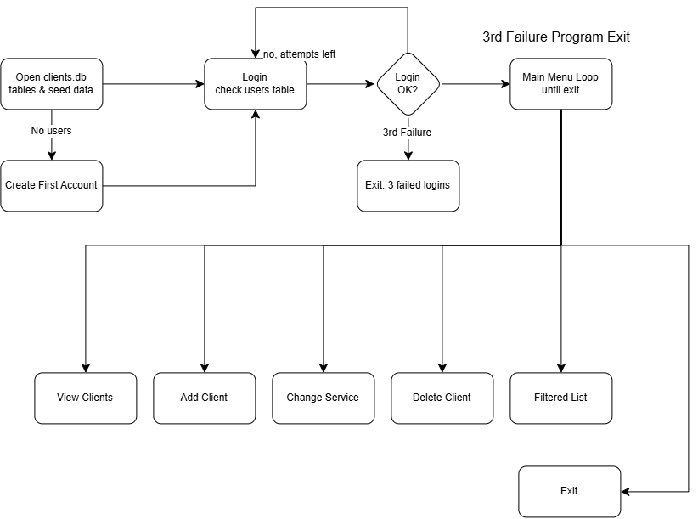

What’s Left
- Modularizing our single file to:
  - Config - .h
  - Database - .h/.cpp
  - Auth - .h/.cpp
  - Input - .h/.cpp
  - Clients - .h/.cpp
  - Report - .h/.cpp
  - Main - .cpp
- Improve current console output to formatted display
- Seed accounts and orders table to perform joins on and enhance filtered reporting
- Narration for GitHub Page.
- Other Considerations:
  - SHA-256 routine for securely hashing vs existing logic

